

Final Year Project Handbook

Version 1.0: Oct 2021
Version 1.2: May 2022
Version 1.3 Oct 2022
Version 1.4 May 2024
Version 1.5 June 2025

Department of Computer Science
Faculty of Engineering and Information Technology

Table of Contents
Chapter 1 Introduction to Final Year Project 1
1.1 Project 1 Execution Procedure 1
1.2 Introduction to FYP2 5
Chapter 2 Project Categories 9
2.1 Introduction 9
2.2 Past Project Titles of 2023-2024 10
Chapter 3 Report Writing and Format 12
3.1 Preliminary pages for both FYP1 and FYP2 reports 12
3.2 List structure 12
3.3 Project Content Structure 12
3.4 Reference Format 13
Chapter 4 Chapter Detail 14
4.1 Outline of Chapter 1 14
4.2 Outline of Chapter 2 14
4.3 Outline of Chapter 3 14
4.4 Outline of Chapter 4 15
4.5 Outline of Chapter 5 15
4.6 Outline of Chapter 6 15
4.9 Outline of Presentation 16
Chapter 5 Project Evaluation 17
Chapter 6 Frequent Ask Questions (FAQ) 18
6.1 Question regarding Supervisor 18
1) May I change supervisor during FYP1? 18
2) May I change supervisor during FYP2? 18
6.2 Question regarding Turnitin Similarity Report 18
6.3 Questions on Project Topic 18
6.4 Questions on AI Tools 18
Chapter 7 Tools or References 19
7.1 Github References 19
7.2 Academic Writing 19
7.3 Server 21
Chapter 8: Work Schedule 27
General Activities for FYP1 27
General Activities for FYP2 27
FYP Exhibition / Tech Fest exhibition 28

Chapter 1 Introduction to Final Year Project

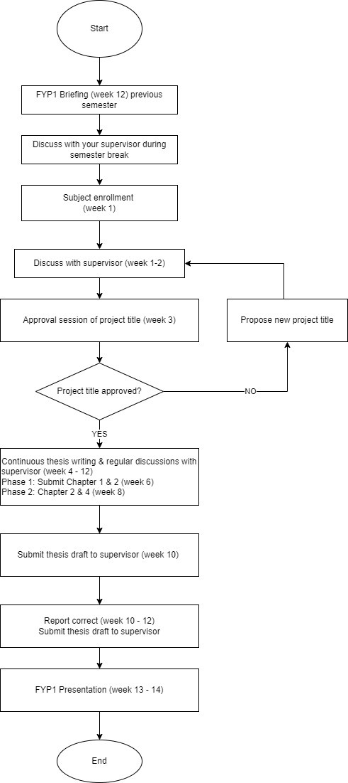
Project 1 Execution Procedure
Figure 1 FYP1 procedure

    - Subject enrolment
Only final year students can enrol Project 1.

Diploma | Subject Code
Diploma in Information Technology | CSIS3003
Diploma in Computer Science | CSIS3044

Bachelor’s degree | Subject Code
Bachelor’s in software engineering | BTIS3103
Bachelor’s in software engineering | BTIS3102

    - Project / Research Category Briefing
At the beginning of the semester, Final Year Project coordinator will brief the students on suitable topic areas. The briefing will include lecturers’ areas of interest, which could be very useful for students in the process of selecting the project title and supervisor.
    - Supervisor appointment
Students are responsible to find a supervisor. The appointed supervisor will supervise the student’s project for both Final Year Project 1 and FYP2. Students, in appointing a supervisor, could use the following tips.
Have a discussion with a few lecturers before appointing, to identify:
      - A supervisor who has sufficient knowledge on the intended project.
      - A supervisor who has the same interest on the intended project.
      - A supervisor has the right to suggest project that contribute to department.
      - Check the list of DCS lecturers and their area of interest at the SUC directory. The link: Southern University College - Lecturer / Staff Directory

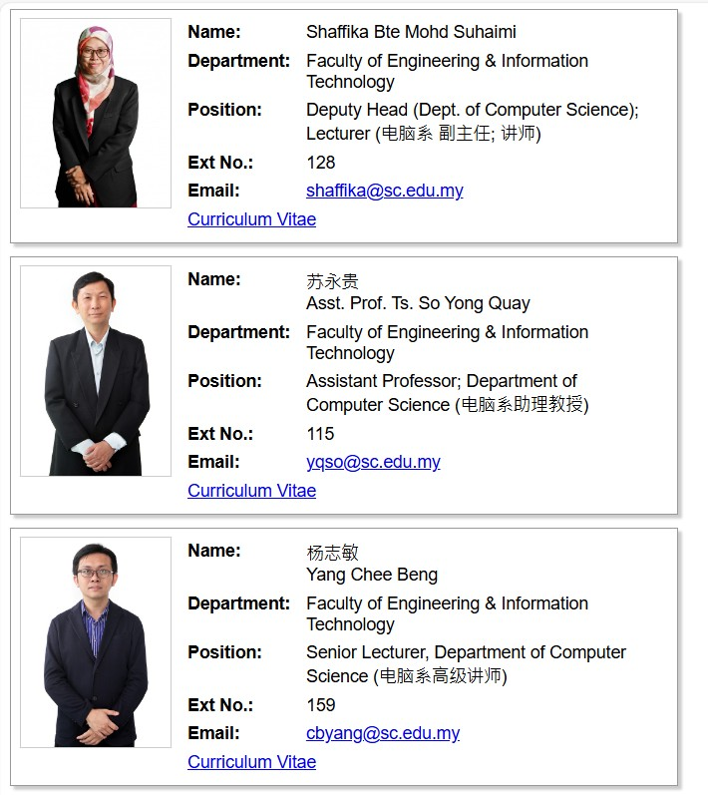

Figure 2 Lecturers' curriculum vitae (updated 7 June 2024 )
    - Final Year Project 1 (FYP1)
This section outlines the execution procedure of FYP1. It also highlights some of the important deliverables or outputs need to be presented by students to the supervisors as well as the evaluators to get a good grade.
      - Project Proposal Submission
Project topics can be a product of students’ own ideas or it can be a suggestion from a prospective supervisor. Upon finding a title that suits you, put together a basic information

search, discuss with your supervisor and prepare a basic proposal. An online project proposal form will be distributed and completed by students.
      - Project Proposal Approval
Upon the submission of the project proposal, project proposal will be reviewed to ensure that:
        - There is no duplication with previous projects in terms of the objectives and scopes for a particular problem domain.
        - Students are clear on the objectives and scopes of their projects
        - Students meet the minimum requirements in terms of technologies to be applied in their projects.
Review sessions are held in the third week of the semester. Students with rejected proposals must submit another proposal within 3 days of receiving the review result.
      - Weekly Supervision Meeting And Logbook
Regular review from supervisors will ensure that students execute their project according to the faculty’s procedure and standards, as well as the project objectives and aims. Student must arrange a minimum of six (6) formal meetings with their supervisors before receiving permission to submit and present their project. However, students are strongly advised to arrange a weekly meeting with the supervisors to address issues related to project execution. All meetings must be recorded in a logbook and the supervisor’s signature of approval of each meeting is required. The logbook form is available at eLearning portal.
Microsoft Teams is the current platform.
      - FYP1 Report Submission
Towards the end of FYP1 cycle, each student is required to submit their project report for evaluation. Students must get their supervisors’ approval before submitting the report softcopy. A designated submission link will be given by week 11 of semester.
      - Presentation Week / Elevator Pitch / Poster Showcase
Students are required to present their FYP1 progress and results achieved for evaluation. The presentation session will be evaluated by student’s supervisor and other lecturers on poster showcase day.
      - FYP1 Report Correction
Students are required to do correction based on the comments given by the supervisors in the coming FYP2.
      - FYP1 Evaluation
At the end of the semester, each student’s project is evaluated to determine that the objectives and scope are adequate and are aligned with project aim. A passing grade in FYP1 is a requirement for FYP2. Evaluation rubric can be view in 1-Project Rubrics (Phase 1 BoSE and DipIT) (SUC)

      - Project Presentation
Twenty (20) minutes is allocated to each student for presentation. 15 minutes for slides presentation and prototype demonstration. 5 minutes for question-and-answer session. The presentation should contain the following items:
        - An introduction on presenter, project title and supervisor
        - An overview of the presentation / presentation outline
        - Project background, aim, objectives and scope of the project
        - Summary of literature review
        - Summary of research / system development methodology
        - List of software and hardware that are required to develop the project
        - Summary of initial findings during FYP1.
        - Discussion on FYP2 execution plan
        - Conclusion of the presentation
Students are advised to follow the subsequent good practices for their project’s presentations:
- Arrive / prepare early for the presentation
- Limit the use of text in slides
- No spelling errors
- Include more figures, pictures, charts, and system screen capture.
- Have eye contact with audience / switch on web camera
- Dress formally
- Speak clearly
- Manage the presentation time within time frame
- Thank the audience for listening

Introduction to FYP2
This section outlines the execution procedure of FYP2. It also highlights some of the important deliverables or outputs need to be presented by students to the supervisors as well as the evaluators to get a good grade.
    - Subject Enrolment
Only final year students passed FYP1 can enrol FYP2

Diploma | Subject Code
Diploma in Information Technology | CSIS3103
Diploma in Computer Science | CSIS3044

Bachelor’s degree | Subject Code
Bachelor’s in software engineering | BTIS3204

    - FYP2 Procedure

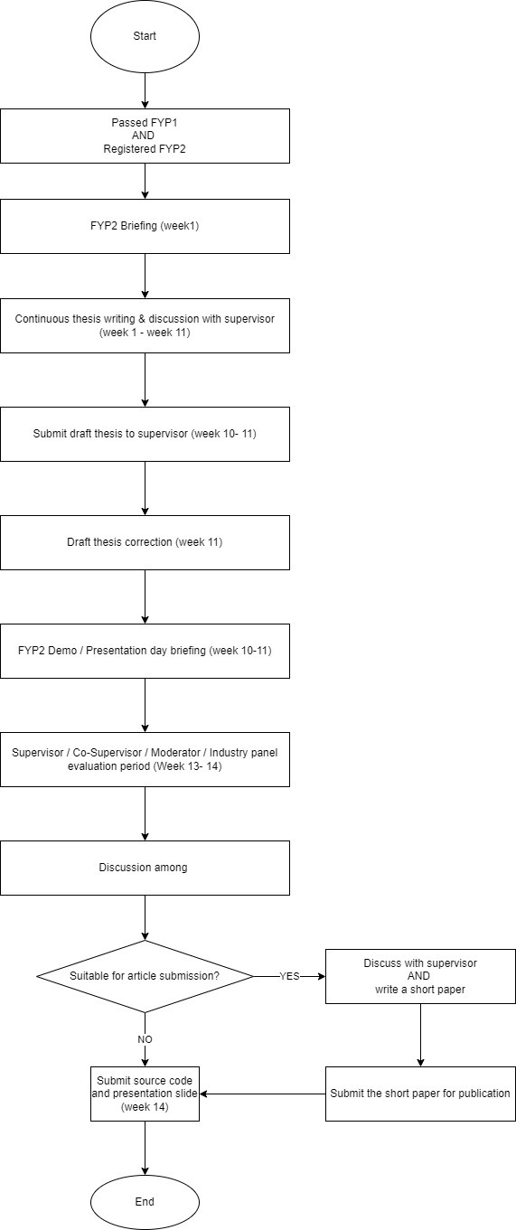
Figure 3 FYP2 procedure

    - FYP2 Pre-Assessment
Students are required to regularly demonstrate their project development updates to their supervisors. These demonstrations act as a benchmark for the supervisor to decide whether the students will proceed with the final presentation.

    - Final Report
The final report is essential to FYP2. The early chapters, Chapters 1,2 and 3 are like FYP1. It must be reminded that the tenses in Chapter 3 must be changed. In FYP1, Chapter 3 presents the plan, while in FYP2 it presents actions already taken. Consequently, the past tense must be used in FYP2.
As part of their progress, students are required to submit drafts of Chapter 4 and 5 to their supervisors for evaluation. Corrections must be done as required. It is hoped that the quality of the student’s project report is improved by having the on-going report assessments.
    - Presentation/ Demo Day
Once the final report has been submitted, students need to prepare themselves for the presentation and demo day.

The presentation for FYP1 is only 20 minutes (15 minutes for slides presentation and 5 minutes for the question-and-answer session). The important points must be included in the slide. The presentation should contain the following items:
      - An introduction on presenter, project tile and supervisor.
      - Presentation outline
      - Project background, aim, objectives and scopes of the project (Chapter 1)
      - Summary of literature review and research/ system development methodology (Chapter 2 and 3)
      - An overview of requirement analysis and design (for system-based projects) / research development and implementation (for research-based projects)
      - Summary of system implementation and testing (for system-based projects) / result and analysis (for research-based projects)
      - Conclusion of the project

    - Report Submission
Students must save thesis report as the required filename and format.

Document | File Name format | Example | File Format
Thesis document | <subject code>_<academic year>_<studentID> | BTIS3204_2021C_B170111B  CSIS3003_2021C_D123456B_D123654A | DOCX
Thesis document | <subject code>_<academic year>_<studentID> | BTIS3204_2021C_B170111B  CSIS3003_2021C_D123456B_D123654A | PDF
Abstract | <subject code>_<academic year>_abstract_<stu dentID> | BTIS3204_2021C_abstract_B170111B  CSIS3003_2021C_D123456B_abstract_D 123654A | PDF
Source Code | GitHub link | https://github.com/lerlerchan/testing2.git | link
Source Code | <subject code>_<academic year>_<studentID> | BTIS3204_2021C_B170111B  CSIS3003_2021C_D123456B_D123654A | ZIP
Poster | <subject code>_<academic year>_poster_<stude ntID> | BTIS3204_2021C_poster_B170111B  CSIS3003_2021C_poster_D123456B_D12 3654A | PPTX
Presentation Slide | <subject code>_<academic year>_slide_<studen tID> | BTIS3204_2021C_slide_B170111B  CSIS3003_2021C_slide_D123456B_D123 654A | PPTX
Presentation Video | <subject code>_<academic year>_presentation_  <studentID> | BTIS3204_2021C_presentation_B170111 B  CSIS3003_2021C_presentation_D123456 B_D123654A | MP4

Designated submission link will be given to students on Week 12. Failure to adhere instruction will result in the suspension of students’ results.

 | FACULTY OF ENGINEERING AND  INFORMATION TECHNOLOGY | Doc. No. | FEIT/DCS/06/2024
 | FACULTY OF ENGINEERING AND  INFORMATION TECHNOLOGY | Rev No. | 01.4
 | FINAL YEAR PROJECT  HANDBOOK | Eff. Date | 4 June 2024
 | FINAL YEAR PROJECT  HANDBOOK | Page No | Page 9 of 24

Chapter 2 Project Categories

2.1 Introduction
There are 2 types of projects which are system development and research based.

Categories | System development | Research-based
Description | - It is based on developing an application, software, or embedded systems.  - The undertaken project must include programming elements with appropriate users’ complexity and meet FYP scope. | - It is based on a research application that includes data analysis, comparative studies or enhancement of techniques or algorithms  - Programming elements must be included in the research project  - It emphasizes on analysis as well as technical writing of the report  - Students are expected to read a few technical papers and able to digest with the help from the appointed supervisors.
Aim | It gives the students an opportunity to conduct exercise as project developer in computer science, information technology and software engineering | It aims at guiding the students with research skills in computer networking, computer security, artificial intelligence, and embedded system.
Examples | - Web based application  - RFID-based project  - Mobile application  - Firmware application | - Application of statistical technique in analyzing network data  - New technique in cryptography  - Image processing  - Implementation of soft computing technique in solving security and network problems
Future career | - Programmer  - Software engineer | - Researchers  - Academic professionals

 | FACULTY OF ENGINEERING AND  INFORMATION TECHNOLOGY | Doc. No. | FEIT/DCS/06/2024
 | FACULTY OF ENGINEERING AND  INFORMATION TECHNOLOGY | Rev No. | 01.4
 | FINAL YEAR PROJECT  HANDBOOK | Eff. Date | 4 June 2024
 | FINAL YEAR PROJECT  HANDBOOK | Page No | Page 10 of 24

Sample | - Cryptography teaching tools  - Workflow automation tools  - Game-based learning tools | - Comparative study n IDS performance  - Malware detection analysis  - EdTech AI analysis

2.2 Past Project Titles of 2023-2024

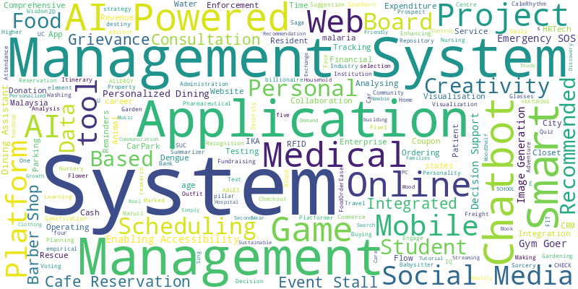
Word Count of Project Titles

Table 1Type of Project Cluster
Program | Cluster | Theme | No of Project Percentage
Diploma | Event Management | Event & Stall Management Systems | 17.6%
Diploma | Healthcare Management | Healthcare & Medical Systems | 17.6%
Diploma | Booking system | Online Booking & Scheduling Systems | 35.3%
Diploma | CSR | Community & Rescue Systems | 11.8%
Diploma | Property Management | Smart Living & Resident Management | 17.6%
Bachelor | Game Development | Game Development Projects | 8.3%
Bachelor | E-Commerce | E-Commerce & Logistics Systems | 25%
Bachelor | Healthcare + AI | Healthcare & AI Integration | 16.7%
Bachelor | Financial | Financial & Productivity Tools | 25%
Bachelor | CSR | Social Impact & Administration Systems | 25%

Chapter 3 Report Writing and Format

Preliminary pages for both FYP1 and FYP2 reports
FYP1 | FYP2
Front Page Format Cover page  Title page Abstract  Acknowledgment page | Front Page Format Cover page  Title page Abstract  Acknowledgment page

List structure
Content page | Title and page number must be equivalent to thesis text
List of tables page | Includes title of all tables and page numbers
List of figures page | Figures include diagrams, photographs, screen capture, graphs, charts, code snippets and others  Include titles of all figures and page numbers
List of abbreviations page | Lists of abbreviations used within the report Listed in alphabetical order
List of terms page | Lists of terminologies used within the text Listed in alphabetical order
List of appendices page | Listed all appendices used within the text.  Appendices are given names such as Appendix A: Context diagram  Appendix B: Source Code Listed in alphabetical order

Project Content Structure
FYP1 | FYP2
Chapter 1: Introduction | Chapter 1: Introduction
Chapter 2: Literature Review | Chapter 2: Literature Review
Chapter 3: Methodology | Chapter 3: Methodology

 | Chapter 4: Design
 | Chapter 5 : Implementation, Testing, Analysis or Evaluation
 | Chapter 6 Conclusion
References | References
Appendixes  Source Code / GitHub Link Similarity Report  AI Chat / Prompt History Paraphrasing tools  AI tools  Video presentation  Any of these can be included accordingly:  - Organizational Chart  - Sample of Interview  - Sample of Questionnaire  - Functions recording link.  Every appendix must have a title | Appendixes  Source Code / GitHub Link Similarity Report  AI Chat / Prompt History Paraphrasing tools  AI tools  Video presentation  Any of these can be included accordingly:  - Organizational Chart  - Sample of Interview  - Sample of Questionnaire  - Functions recording link  - User manual  Every appendix must have a title

Reference Format
The project is an essential component of the program. It is important that detection of any form of plagiarism in project work will be taken very seriously. The references can be written by using American Psychological Association, APA referencing style. Student may refer to SUC library for assistance Or https://library.sc.edu.my/files/Quick%20Reference%20Guide_APA_24%20May%202021.pd f

Chapter 4 Chapter Detail
Students must discuss with supervisors regarding their report writing. Supervisors has the right to add or eliminate some minor topic.

Outline of Chapter 1
Applicable to FYP1 and FYP2.

System Development Based | Research Based
Chapter 1: Introduction  - Background Research  - Objectives  - Scope  - Summary | Chapter 1: Introduction  - Background Research  - Objectives  - Scope  - Research Contribution  - Summary

Outline of Chapter 2
Applicable to FYP1 and FYP2.

System Development Based | Research Based
Chapter 2: Literature Review  - Introduction  - Inter-organisation case study (if any)  - Current system analysis  - Compare between 3 existing systems  - Literature review on technology used  - Summary | Chapter 2: Literature Review  - Introduction to case study  - Problem formulation  - Suggestions to solve identified problems  - summary

Outline of Chapter 3
Applicable to FYP1 and FYP2

System Development Based | Research Based
Chapter 3: Methodology  - Introduction  - Methodology choice and justification  - Phases within the chosen methodology / Planning  - System requirement analysis:  - hardware  - software | Chapter 3: Methodology  - Introduction  - Operational Framework / Research Workflow  - Justification  - Tools  - Data  - Techniques  - Performance measurement

- Gantt Chart  - Financial Justification  - Summary | - Gantt Chart  - Summary

Outline of Chapter 4
Applicable to FYP1 and FYP2.

System Development Based | Research Based
Chapter 4: Design  - Introduction  - Use Case Diagram  - Class Diagram / Sequence Diagram (Choose either one)  - Entity Relationship Diagram (ERD)  - Data Flow Diagram (DFD)  - Activity Diagram  - Activity Diagram  - System Architecture  - Summary | Chapter 4 Experimental Setup  - Introduction  - Proposed Solution  - Experiment design  - Parameter and testing methods  - Summary
* Discuss with supervisor

Outline of Chapter 5
Applicable to FYP2 Only

System Development Based | Research Based
Chapter 5: Implementation, Testing, Analysis or Evaluation  - Introduction  - Implementation  - Testing  - Analysis or Evaluation  - Summary | Chapter 5: Implementation  - Introduction  - Experiment implementation  - Analysis or Evaluation  - Summary

Outline of Chapter 6
Applicable to FYP1 and 2

System Development Based | Research Based
Chapter 6: Conclusion  - Introduction  - Achievements  - Limitation  - Future work / Recommendation | Chapter 6: Conclusion  - Introduction  - Limitation  - Future work / recommendation  - Summary

6.5 Summary

4.9 Outline of Presentation
FYP1: 15 minutes presentation and 5 minutes question and answer session

System Development Based | Research Based
- Introduction  - Overview of presentation  - Project background, objectives, and scopes  - Summary of literature review / Methodology  - Overview of requirement analysis and design  - List of software and hardware  - Summary of initial finding during FYP1 (EG: analysis of data collected from survey)  - Discussion on FYP2 execution plan  - Conclusion  Question and answer session | - Introduction  - Overview of presentation  - Project background, objectives, and scopes  - Summary of literature review / methodology  - List of software and hardware  - Summary of initial finding during FYP1 (EG: analysis of data collected from survey)  - Discussion on FYP2 execution plan  - Conclusion  Question and answer session

FYP2: 15 minutes presentation and 5 minutes question and answer session

System Development Based | Research Based
- Introduction  - Overview of presentation  - Project background, objectives, and scopes  - Summary of literature review / Methodology  - Overview of requirement analysis and design  - Summary of system implementation  - Prototype demonstration  - Conclusion  Question and answer session | - Introduction  - Overview of presentation  - Project background, objectives, and scopes  - Summary of literature review / methodology  - Research development and implementation  - Result and analysis  - Conclusion  Question and answer session

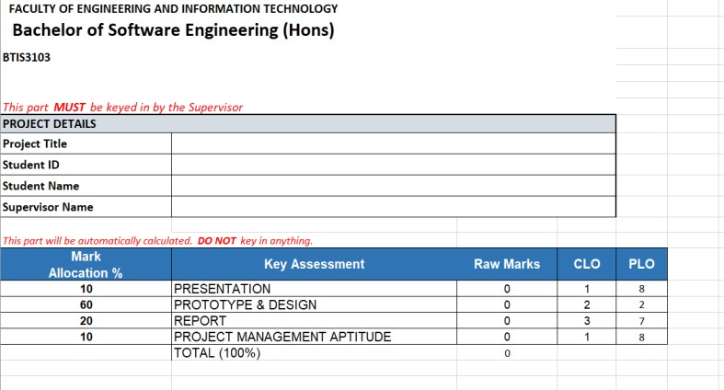
Chapter 5 Project Evaluation
Figure 4 Sample of FYP1 rubric
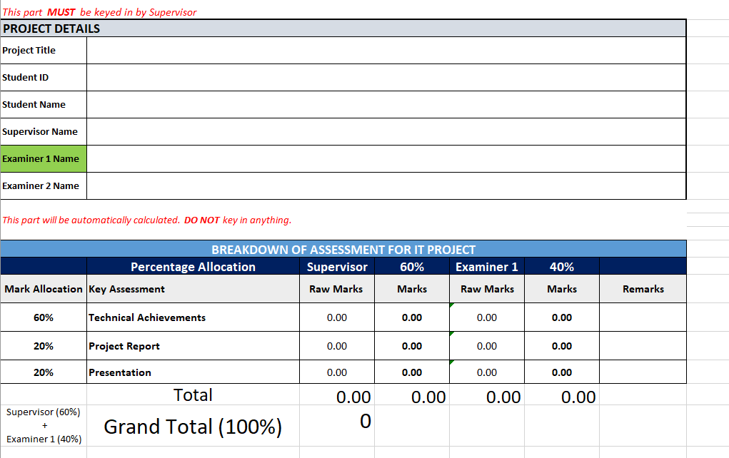
Figure 5 Sample of FYP2 Rubric

Chapter 6 Frequent Ask Questions (FAQ)

Question regarding Supervisor

May I change supervisor during FYP1?
Student is not allowed to change supervisor. Thus, it is best to discuss with different lecturers before subject enrolment.

May I change supervisor during FYP2?
Student is not allowed to change supervisor due to project requirements. Student is allowed to change supervisor IF
      - Supervisor is not available
      - Supervisor recommend a change of person in charge for better academic purpose

What is the MS Team Code for BoSE? Diploma?
BoSE FYP1 / FYP2: 94po3q6
DIP Project 1/ Project2 / Project: 2il6ljo

Where is the document template?
BoSE FYP1 / FYP2 : https://southernuniversitycollege.sharepoint.com/:f:/s/BTIS3204Project2Briefing/Eq4UFGMOKC9IuZQ5QwW4sKsBqNI2PFqNn7szXXAZXwX9xg?e=R6IRTa

DIP Project 1/ Project 2/ Project:
https://southernuniversitycollege.sharepoint.com/:f:/s/CSIS3103CSIS3044Briefing/Emh8rpj8aqVKi58hlLjtH6wBA8vhpWuvV_gnPzqj2k8YPQ?e=VACbh2

What is the Turnitin ID and enrolment key?
Turnitin ID: 48920141
Enrolment Key: 2025b

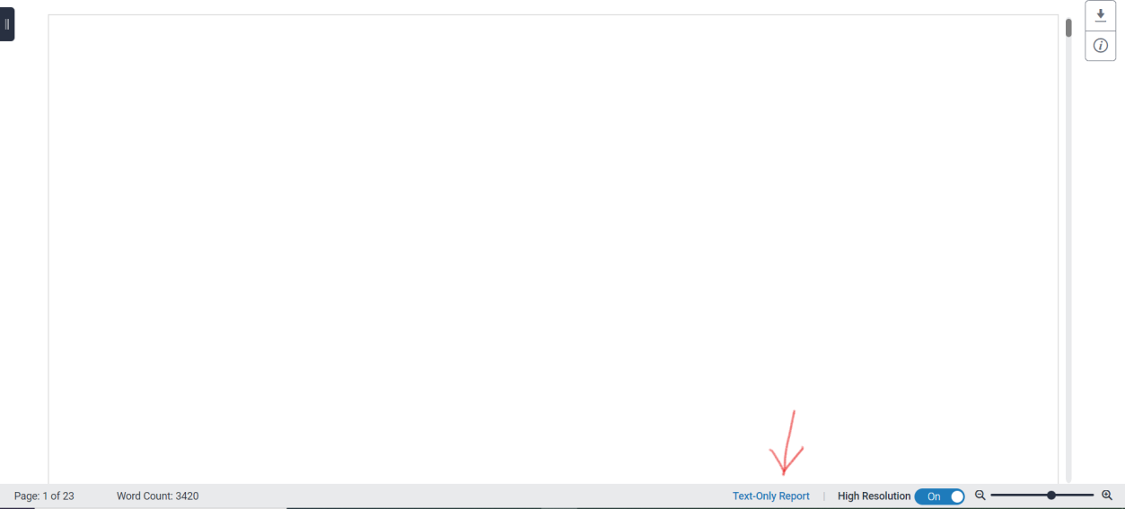
Question regarding Turnitin Similarity Report
Screen capture your Text-Only Report for Appendix B

Questions on Project Topic
- Can student change project title during FYP2?
Student is not allowed to change project title due to time constraint.

6.4 Questions on AI Tools

- Can student use AI tools in assistance?
Students are permitted to use any open-source AI tools or API keys. However, they must complete the AI Declaration Form. Additionally, students are required to include screenshots of the tools used or the prompt history in the Appendix

Chapter 7 Tools or References

Github References
Github: https://github.com/
GitHub desktop: https://desktop.github.com/

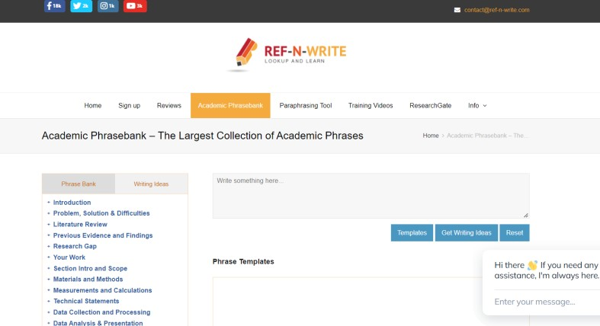
Academic Writing
Phase bank: https://www.ref-n-write.com/academic-phrasebank/

Summarise an article: https://getdigest.com/en
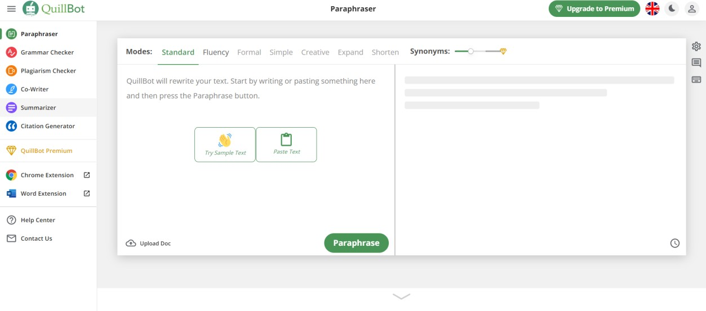
Paraphrasing Tool: Paraphrasing Tool | QuillBot AI

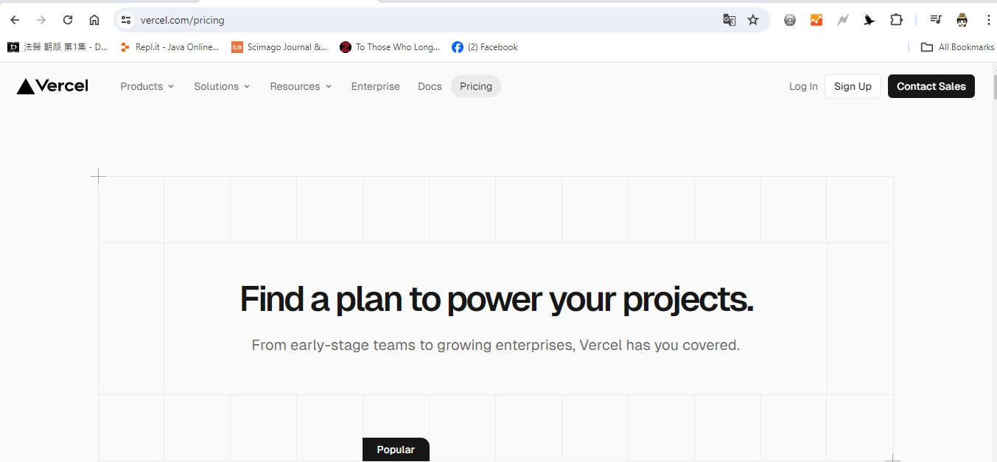
Server

https://vercel.com/
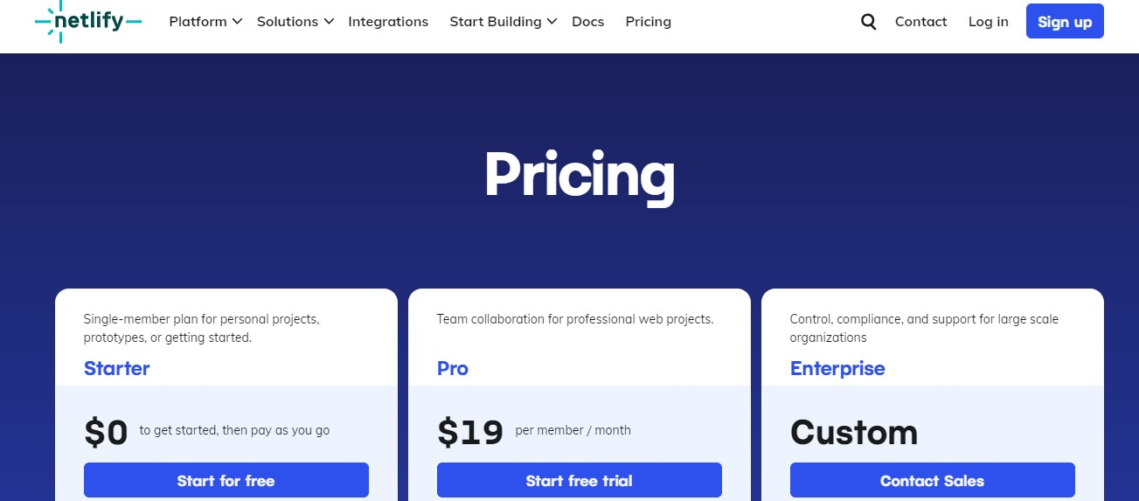
https://www.netlify.com/



https://azure.microsoft.com/en-us/pricing/offers/ms-azr-0170p


https://www.000webhost.com/

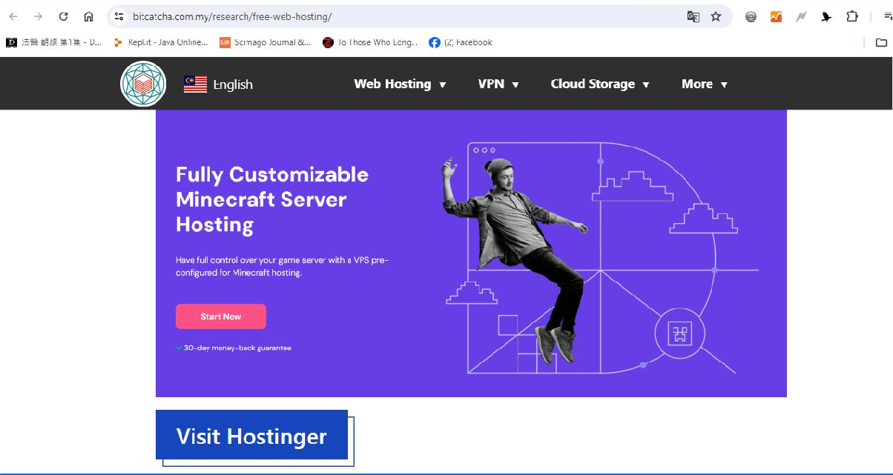

https://www.bitcatcha.com.my/research/free-web-hosting/

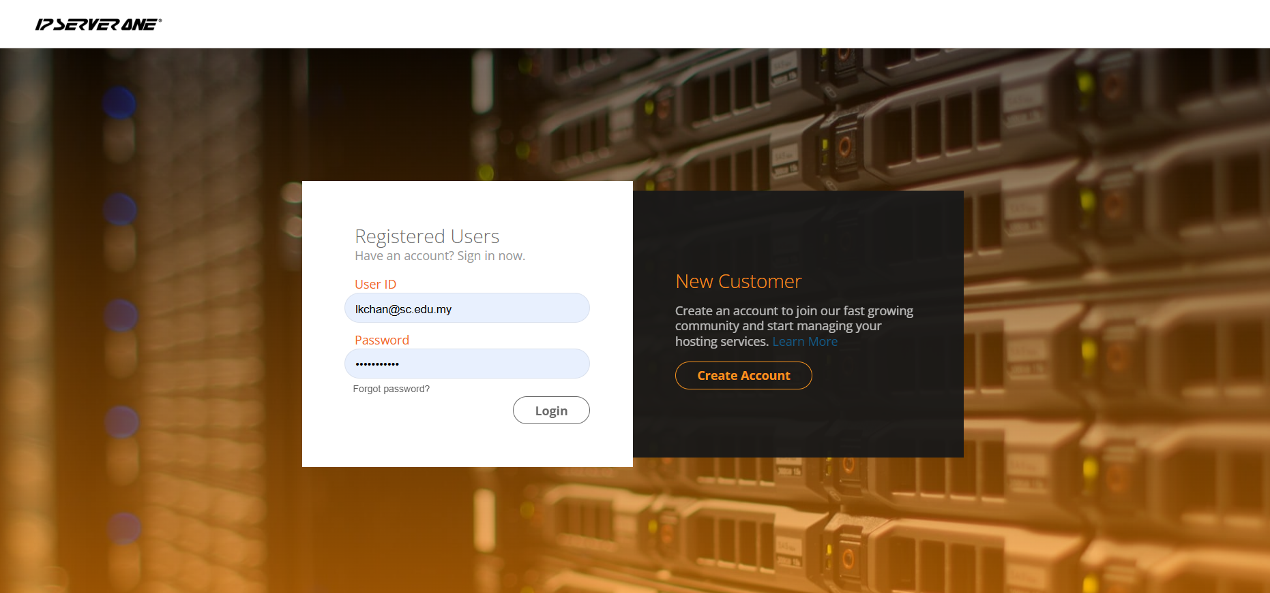
ONE minute RM500 cloud credit IA Business Summit 2023 – IP ServerOne Solutions Sdn. Bhd.

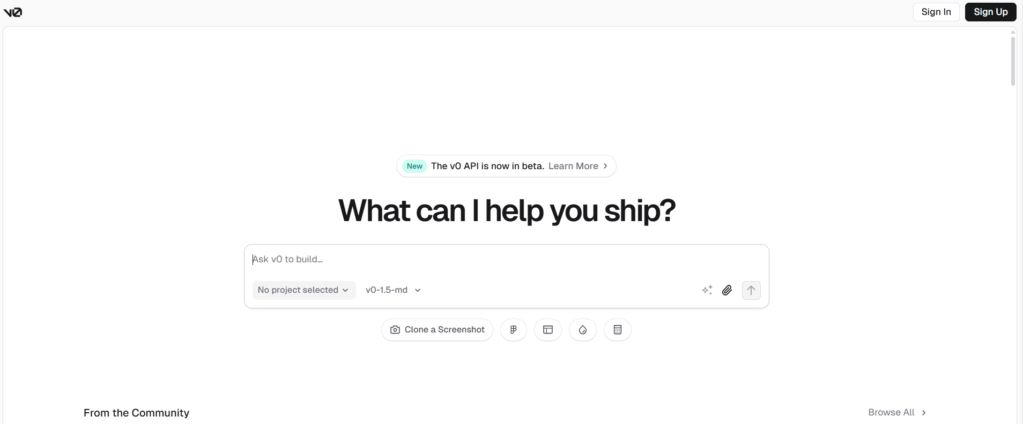

v0 by Vercel

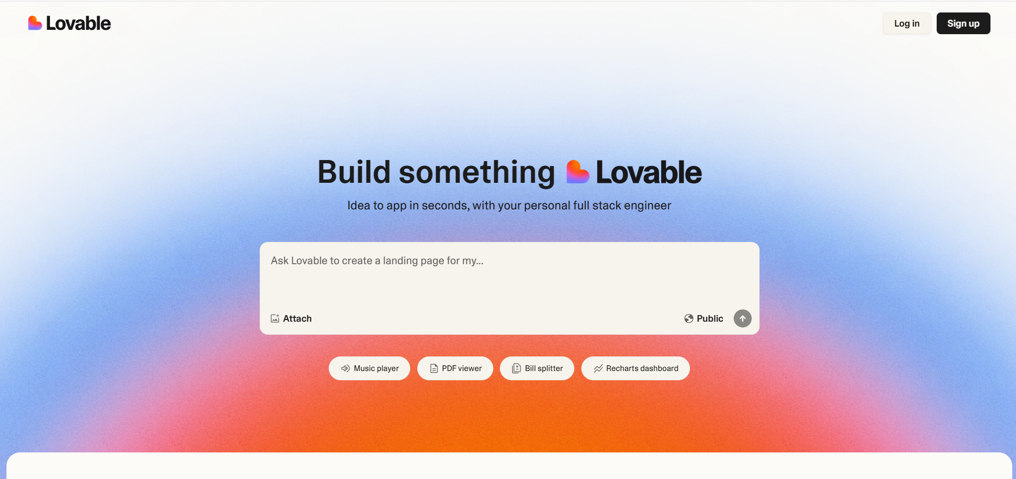
Lovable

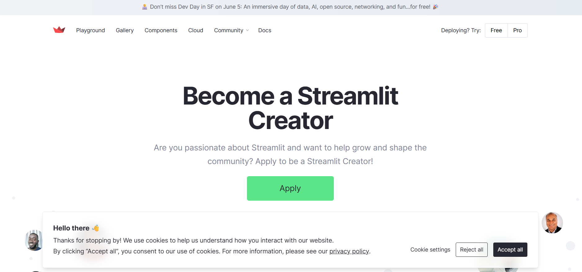

Streamlit • A faster way to build and share data apps

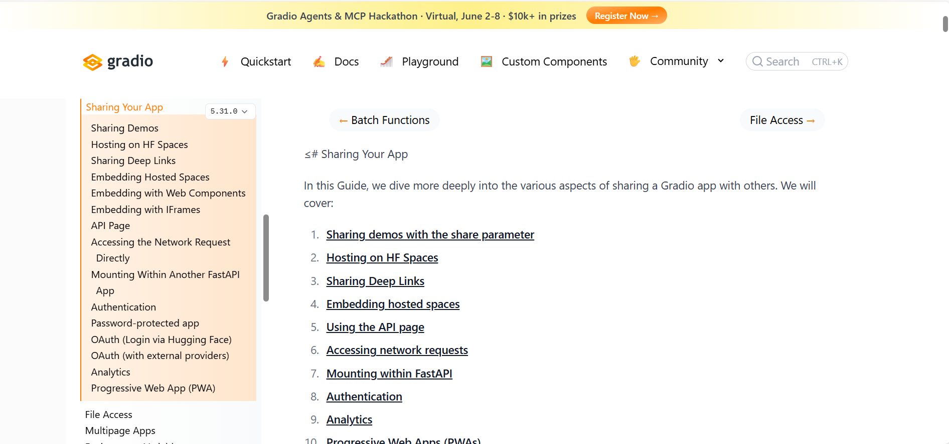
Sharing Your App

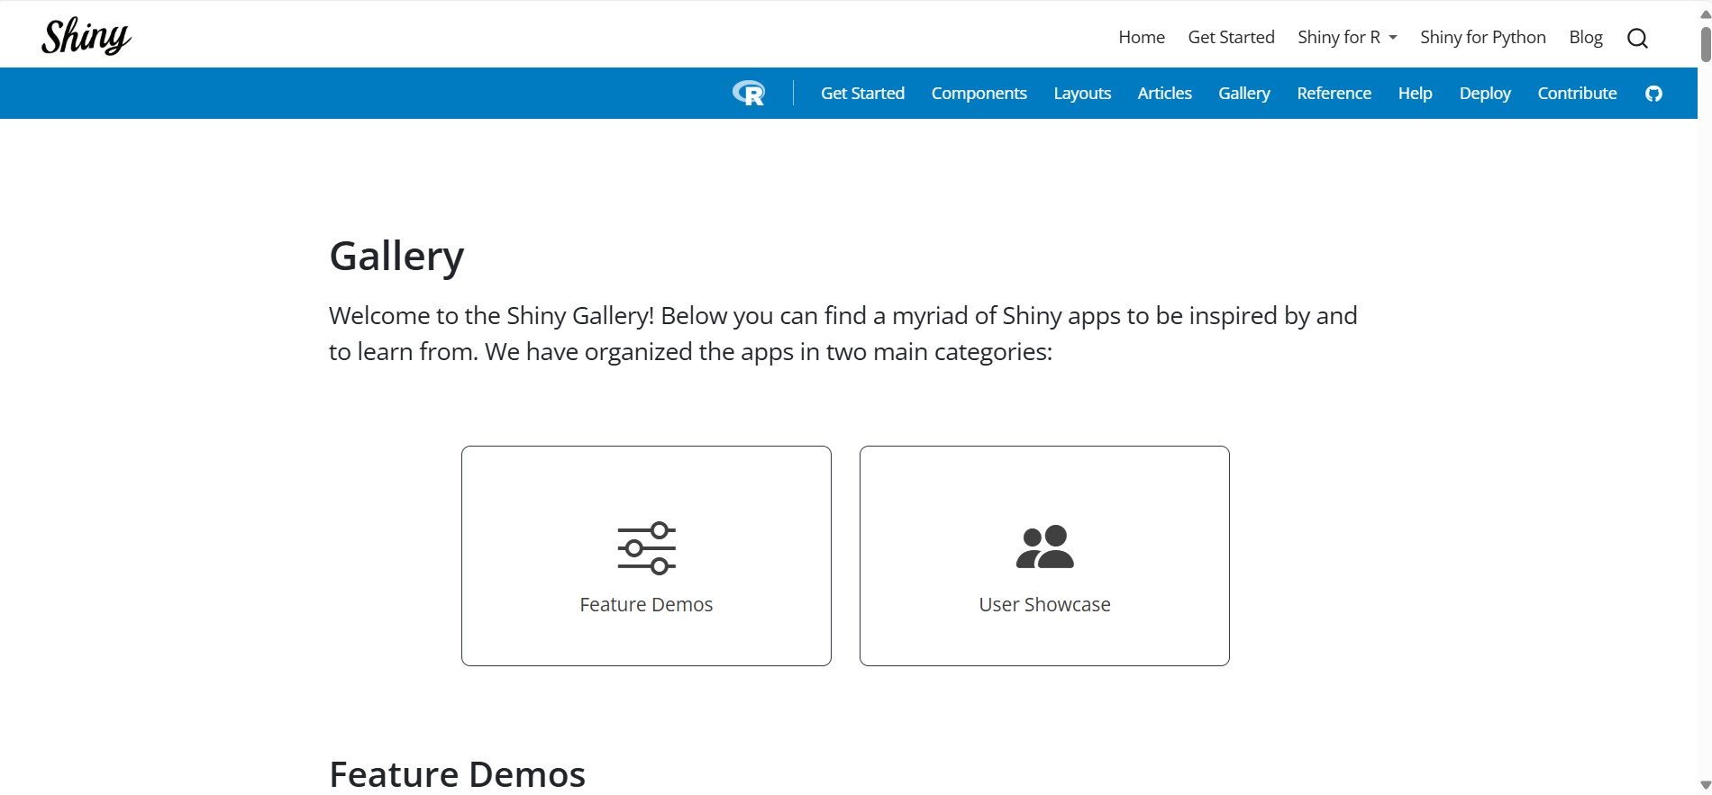

Shiny for R Gallery

Chapter 8: Work Schedule

General Activities for FYP1
Week | Activity | Person(s) Responsible
All | Project Agent in assistance of final year project / project | Student, supervisor, project coordinator
1-2 | Determination of project title | Student & supervisor
1-2 | Research methodology class (optional) | Student,  Project coordinator
3 | Submit project title and proposal | Student
3 | Confirmation of project title | Supervisor & Project coordinator
4 - 10 | Continuous thesis writing  Regular discussion with supervisor | Student & supervisor
10 | Submit thesis draft to supervisor | Student
11 | Report correction | Student & Supervisor
12 | Report submission to supervisor  Report submission to project coordinator | Student, supervisor  Project coordinator
13 - 14 | Presentation with supervisor | Student & supervisor
14 - 16 | Mark submission | Supervisor
16 | Compilation of marks via e-OBE  Compilation of ePortfolio | Project coordinator

General Activities for FYP2
Week | Activity | Person(s) Responsible
All | Project Agent in assistance of final year project / project | Student, supervisor, project coordinator
1 | FYP exhibition Proposal | Project coordinator
6 | Supervisors submit 2 projects for competition | Supervisor, project coordinator
 | FYP Coordinator review project progress for competition
1-11 | Continuous thesis writing & discussion with supervisor | Student & supervisor
1-11 | System development / coding | Student
10 | Submit thesis to supervisor | Student & supervisor
11 | Thesis correction or improvement | Student & supervisor
12 | Submit thesis/ abstract / source code to project coordinator | Student  Project coordinator
12 | Arrange presentation session with examiner | Project coordinator Panel
13 - 14 | Presentation session / FYP exhibition | Student, supervisor, project coordinator & panel
14 - 15 | Source code submission | Student  Project coordinator
14 - 16 | Evaluation by examiner and supervisor | supervisor & panel
14 - 16 | Rubric submission to designated folder | Supervisor  project coordinator
14 - 16 | Mark submission to SUC Portal | Supervisor
16 | Compilation of marks via e-OBE | Project coordinator
16 | Compilation of top-grade thesis | Project coordinator
 | Select Q1 thesis to library | Project coordinator

FYP Exhibition / Tech Fest exhibition

- The Final Year Project (FYP) Exhibition will be held annually during Semester C.
- It is proposed that the event be hosted in Room IEB 407, which is equipped with power sockets.
- The exhibition is proposed to take place between Weeks 12 and 14 of Semester C.
- Project selection for the exhibition will be supported by Microsoft Copilot, utilizing a predetermined exhibition selection rubric.
- The duration of the exhibition will be three hours, tentatively scheduled for Wednesdays from 1:00 PM to 4:00 PM.
- A total of 12 groups will present, comprising 8 groups from the Bachelor’s program and 4 groups from the Diploma program.
- Students are encouraged to use external monitors to enhance the visibility and presentation of their projects during the exhibition.
- The predetermined selection rubric for the exhibition includes:
  - Project Progress – 30%
  - Presentation Quality – 30%
  - Technical Functionality – 40%
- Supervisors are permitted to nominate supervisees from both Semester B and Semester C for participation in the exhibition.

Week | Activity | Person(s) Responsible
1 | FYP exhibition Proposal | Project coordinator
2 | Venue approval  Prepare floor plan layout | AGO
5 | Prepare invitation email | Project coordinator
6 | Invitation to internship companies PIC / Board of director/ Top management | Project coordinator  Head of Department
 | Supervisors submit 2 projects | Supervisor, project coordinator
7 | Select suitable project for exhibition | Project coordinator
8 | Compile exhibition guest list  Prepare door gift for visitors | Project coordinator
 | Prepare competition itinerary  - VP give welcome speech  - BoD give speech  - Dean give speech  - Exhibition  - Collect feedback from visitors  - Closing speech by HoD  - Presentation of cert by HoD to students | Project Coordinator
 | Request HoD to invite top management | HoD
9 | Submit floor plan layout | AGO
10 | Confirmed project list | Project Coordinator
11 | Prepare exhibition participation Cert | SUCCESS, SUCCESS advisor
12-14 | Exhibition  Moderation | Supervisor, project coordinator
15 | Compile visitors’ feedback | Project Coordinator

0000

